**Power BI Assignment 2**

1. Explain the advantages of Natural Queries in PowerBi with an example?

**Ans:** Some advantages of using natural language querying tools include the following capabilities.

### Simplifying employee access to BI data

Corporación Hijos de Rivera S.L., the Spain-based producer of Estrella Galicia beer and other beverage brands, is one early adopter of natural language querying to improve access to BI data for frontline business workers. JJ Delgado, the company's chief digital officer, has been working to add a [natural language generation (NLG)](https://www.techtarget.com/searchenterpriseai/definition/natural-language-generation-NLG) interface on top of its MicroStrategy BI system -- an [augmented analytics application](https://www.techtarget.com/searchbusinessanalytics/feature/5-augmented-analytics-examples-in-the-enterprise) that he said enables users to run new types of queries and more easily understand the results.

"We believe augmented analytics changes the game for us," Delgado said. "Not only can our users connect to the MicroStrategy platform to surface business information and get the insights they're looking for by asking Alexa a question, but they can also, through our NLG technology implementation, read intelligent narratives that describe the analyses they are seeing."

Marge Breya, chief marketing officer at MicroStrategy, said the BI vendor's experience with customers shows there are "large swaths of corporate employees that need immediate insights" from BI systems. But many business users lack the comfort level or skills to interpret complex [graphs and other data visualizations](https://www.techtarget.com/searchbusinessanalytics/tip/12-data-visualization-techniques-for-effective-BI-applications) themselves, she added.

Voice interfaces like Alexa will make it easier for these users to [take advantage of voice-enabled technology](https://www.techtarget.com/searchcio/opinion/What-technical-challenges-face-voice-AI-technology-There-are-many) to ask questions and get understandable answers in a natural manner, Breya said. For example, MicroStrategy has created NLP capabilities that can formulate a data visualization from a sentence of text entered by a user; it also has added Alexa connectivity and chatbot support.

### Driving deeper business insights

Some experts believe that natural language querying could help drive deeper insights by lowering the expertise required to interact with [BI and analytics tools](https://www.techtarget.com/searchbusinessanalytics/feature/How-to-evaluate-and-select-the-right-BI-analytics-tool). Instead of being limited to [BI analysts](https://www.techtarget.com/searchbusinessanalytics/feature/What-does-a-business-intelligence-analyst-do), data scientists and other skilled analytics professionals, the tools become directly accessible to business users, which Gartner calls *democratizing analytics*.

Natural language queries enables BI users to explore data without having to write code.

In addition, it often takes multiple steps to get useful results from querying BI and analytics data, said Micha Breakstone, co-founder and head of R&D at conversational analytics platform vendor Chorus.ai. "Many deep insights come about through careful iterative processes where queries lead to noisy results with a very subtle signal hidden within, and through careful clean-up, cross-analysis and projections, the noise is cleaned, the signal becomes clearer and deep insights emerge," Breakstone said.

He added that the ability to [use NLP for querying](https://www.techtarget.com/searchbusinessanalytics/ehandbook/NLP-uses-in-BI-and-analytics-speak-softly-but-carry-a-big-stick) could vastly simplify such iterations and enable faster progress as data specialists and non-technical business experts collaborate more effectively, which ultimately should lead to [better analytics insights](https://www.techtarget.com/searchbusinessanalytics/feature/Enterprise-analytics-benefits-of-natural-language-processing).

Natural language querying also hides some of the complexity of locating related data in multiple systems. For example, if a user might be challenged in searching for a data element on credit card numbers across several data sources that use different names for the field, a natural language query could help identify and locate the various instances, said Gal Ziton, CTO and co-founder of Octopai, a metadata management platform vendor.

### Reducing confusion about analytics results

To aid in the querying process, NLG technology enables BI tools to create narratives from data so that trends, variances and exceptions can be both visualized and described. The adage "A picture is worth a thousand words" is often true, but in many cases, there are different ways to interpret that picture -- or data visualization.

"Narration describes a visualization so there is no ambiguity [about] what it means," said John Hagerty, vice president of product management for business analytics at Oracle. Additionally, for many [BI team members](https://www.techtarget.com/searchbusinessanalytics/answer/Key-roles-and-responsibilities-of-a-business-intelligence-team) or business analysts, creating a narration of analytics results takes up huge amounts of time. NLG accelerates that activity in a profound way, Hagerty said.

### Applying structure to unstructured data

The flip side of natural language querying on the front end lies in applying NLP techniques to help analyze [unstructured data](https://www.techtarget.com/searchbusinessanalytics/definition/unstructured-data). "NLP makes sense of that unstructured data, making it organized, queryable and searchable," said Stephen Blum, founder and CTO of PubNub, a data management API provider.

A common example of unstructured data is social media data on a company's brand. Business executives want to know what people are saying and how they feel about the brand. NLP can both categorize social media mentions by topic and analyze the sentiments in posts. Those kinds of capabilities give business users a new way to query and analyze all the unstructured data in corporate systems, which an often-cited statistic says could be [up to 80%](https://www.capgemini.com/2018/08/reorganizing-unstructured-data/) of enterprise data overall.

1. Explain Web Front End(WFE) cluster from Power BI Service Architecture?

**Ans:** The Power BI implementation includes two major clusters. Such as a Web Front End (WFE) cluster, and a Back-End cluster.

The Web Front End cluster manages the initial connection between the back end cluster and the clients. It uses AAD (Azure Active Directory) to authenticate clients. Moreover, it provides various tokens for connecting clients to the Power BI service. Besides, Power BI also uses the Azure Content Delivery Network (CDN) to distribute the content efficiently. Besides, it uses ATM (Azure Traffic Manager) to distribute content to users based on various geographical locations.

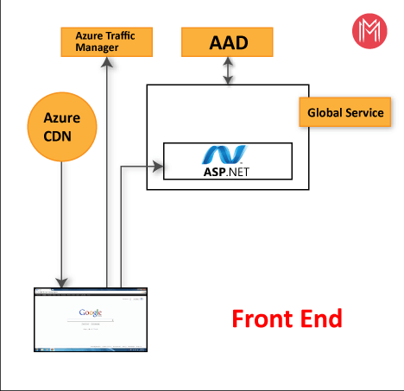

A WFE cluster consists of an ASP.NET website running in the [Azure App Service Environment](https://learn.microsoft.com/en-us/azure/app-service/environment/intro). When users attempt to connect to the Power BI service, the client's DNS service may communicate with the Azure Traffic Manager to find the most appropriate (usually nearest) datacenter with a Power BI deployment. For more information about this process, see [Performance traffic-routing method for Azure Traffic Manager](https://learn.microsoft.com/en-us/azure/traffic-manager/traffic-manager-routing-methods#performance-traffic-routing-method).

Static resources such as \**.js*, \**.css*, and image files are mostly stored on Azure Content Delivery Network (CDN) and retrieved directly by the browser. Note that Sovereign Government cluster deployments are an exception to this rule, and for compliance reasons will omit the CDN and instead use a WFE cluster from a compliant region for hosting static content.

1. Explain Back End cluster from Power BI Service Architecture?

**Ans:** The Power BI implementation includes two major clusters. Such as a Web Front End (WFE) cluster, and a Back-End cluster.

The Back End Cluster is useful to maintain various reports, storage, data sets, and other services under Power BI. In the BEC, the client has only two points to interact directly with the information or data. These are the Gateway Role and Azure API Management. Moreover, these components are useful for various services like load balancing, authentication, and routing, etc.

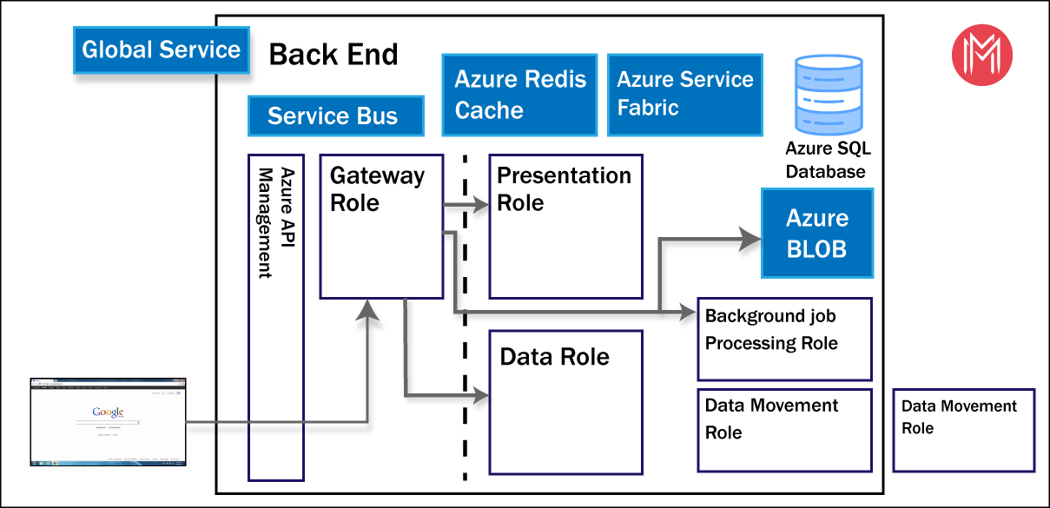

Each back-end cluster is stateful and hosts all the data of all the tenants assigned to that cluster. A cluster that contains the data of a specific tenant is referred to as the tenant's home cluster. An authenticated user's home cluster information is provided by Global Service and used by the Web Front End to route requests to the tenant's home cluster.

Each back-end cluster consists of multiple virtual machines combined into multiple resizable-scale sets tuned for performing specific tasks, stateful resources such as SQL databases, storage accounts, service buses, caches, and other necessary cloud components.

Tenant metadata and data are stored within cluster limits except for data replication to a secondary back-end cluster in a paired Azure region in the same Azure geography. The secondary back-end cluster serves as a failover cluster in case of regional outage, and is passive at any other time.

Back-end functionality is served by micro-services running on different machines within the cluster's virtual network that are not accessible from the outside, except for two components that can be accessed from the public internet:

* Gateway Service
* Azure API Management

1. What ASP.NET component does in Power BI Service Architecture?

Ans: ASP.NET is a web development platform, which provides a programming model, a comprehensive software infrastructure and various services required to build up robust web applications for PC, as well as mobile devices.

ASP.NET works on top of the HTTP protocol, and uses the HTTP commands and policies to set a browser-to-server bilateral communication and cooperation.

ASP.NET is a part of Microsoft .Net platform. ASP.NET applications are compiled codes, written using the extensible and reusable components or objects present in .Net framework. These codes can use the entire hierarchy of classes in .Net framework.

The ASP.NET application codes can be written in any of the following languages:

* C#
* Visual Basic.Net
* Jscript
* J#

ASP.NET is used to produce interactive, data-driven web applications over the internet. It consists of a large number of controls such as text boxes, buttons, and labels for assembling, configuring, and manipulating code to create HTML pages.

ASP.NET component in Power BI Service Architecture

Whether the page you're going to embed your report in is a server-rendered page, such as an ASP.NET MVC page, or a client-rendered view, such as an Angular View Component, you first need to obtain an Embed token from the Power BI service. To obtain an Embed token, your app needs to authenticate with Azure Active Directory. That needs to happen on the back-end because it requires using the Application Secret you obtained while registering your application, and there's no way to use that secret securely from the front-end code. Java/C code for an API controller that authenticates and obtains an Embed token for your report and returns that to the client JavaScript that calls this API method. This code resides in an ASP.NET Core application. You'll need to add a couple of NuGet packages to your ASP.NET Core project to bring in the needed libraries for communications with the Power BI API:

* Microsoft.PowerBI.Api
* Microsoft.IdentityModel.Clients.ActiveDirectory

The ASP.NET Core API project for the sample code also exposes a data API so that the client application can also edit Sales records or add new ones; you can see that you can edit the data, refresh the report view, and see the changed data immediately in the report.

To obtain an Embed token, your app needs to authenticate with Azure Active Directory on the back-end because it requires using the Application Secret you obtained while registering your application.

1. Compare Microsoft Excel and PowerBi Desktop on the following features:

**Ans:**

|  |  |  |
| --- | --- | --- |
| **Particulars** | **Excel** | **Power BI Desktop** |
| Data import | Excel can connect and use data from a huge range of different sources | With Power BI, you can extract data from virtually anywhere – any application, platform, or software. This gives Power BI users access to a massive range of data sources. Usually, this is done using Power BI desktop. |
| Data transformation | There are less than 15 visualisation options in Excel, which can be a drawback if you’re looking to get creative with your analysis. | There are over 50 different visualisations in Power BI, including column charts, line charts, bar graphs and scatter plots. These allow you to analyse your data from every angle! |
| Modeling | Excel will handled simple & structured data. | Power BI can cope with very complex modelling if you’re looking to build a complex data model, |
| Reporting | Excel doesn’t offer as much support for sharing and collaborating on reports. | Intuitive report sharing is built into Power BI.reports can be viewed across multiple devices, and Power BI makes it easy to share reports with your team members, even if they don’t have Power BI themselves. |
| Server Deployment | The Office Deployment Tool (ODT) is a command-line tool that you can use to download and deploy Click-to-Run versions of Office, such as Microsoft 365 Apps for enterprise, to your client computers. | Deployment pipelines enable creators to develop and test Power BI content in the Power BI service, before the content is consumed by users. The content types include reports, paginated reports, dashboards, datasets and dataflows. |
| Convert Models | Data model using Power Pivot, and create interactive reports with Power View that we can publish, protect, and share. | The DirectQuery to the Power BI Dataset will enable us to bring the Power BI dataset’s data into a composite model, which gives us the ability to do further data modeling in the chained dataset |
| Cost | Payment Tool. | It has a free version and a payment version. |

1. List 20 data sources supported by Power Bi desktop.

**Ans:** Following are the data sources supported by Power Bi desktop:

* Excel Workbook
* Text/CSV
* XML
* JSON
* Folder
* PDF
* Parquet
* SharePoint folder
* SQL Server database
* Access database
* SQL Server Analysis Services database
* Oracle database
* IBM Db2 database
* IBM Informix database (Beta)
* IBM Netezza
* MySQL database
* PostgreSQL database
* Sybase database
* Teradata database
* SAP HANA database
* SAP Business Warehouse Application Server
* SAP Business Warehouse Message Server
* Amazon Redshift
* Impala
* Google BigQuery
* Google BigQuery (Azure AD)(Beta)
* Vertica
* Snowflake
* Essbase
* Actian (Beta)
* Amazon Athena
* AtScale cubes
* BI Connector
* Data Virtuality LDW
* Denodo
* Dremio Software
* Dremio Cloud (Beta)
* Exasol
* Indexima
* InterSystems IRIS (Beta)
* Jethro (Beta)
* Kyligence
* Linkar PICK Style / MultiValue Databases (Beta)
* MariaDB
* MarkLogic
* TIBCO® Data Virtualization